|  |  |
| --- | --- |
| **EX NO:6** | **ONLINE COURSE RESERVATION SYSTEM** |

SEQUENCE DIAGRAM:

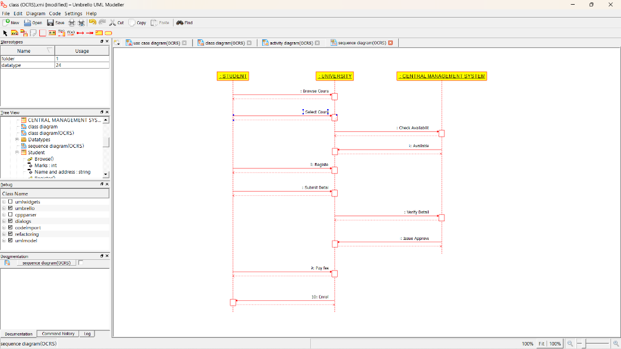

COLLABORATION DIAGRAM:

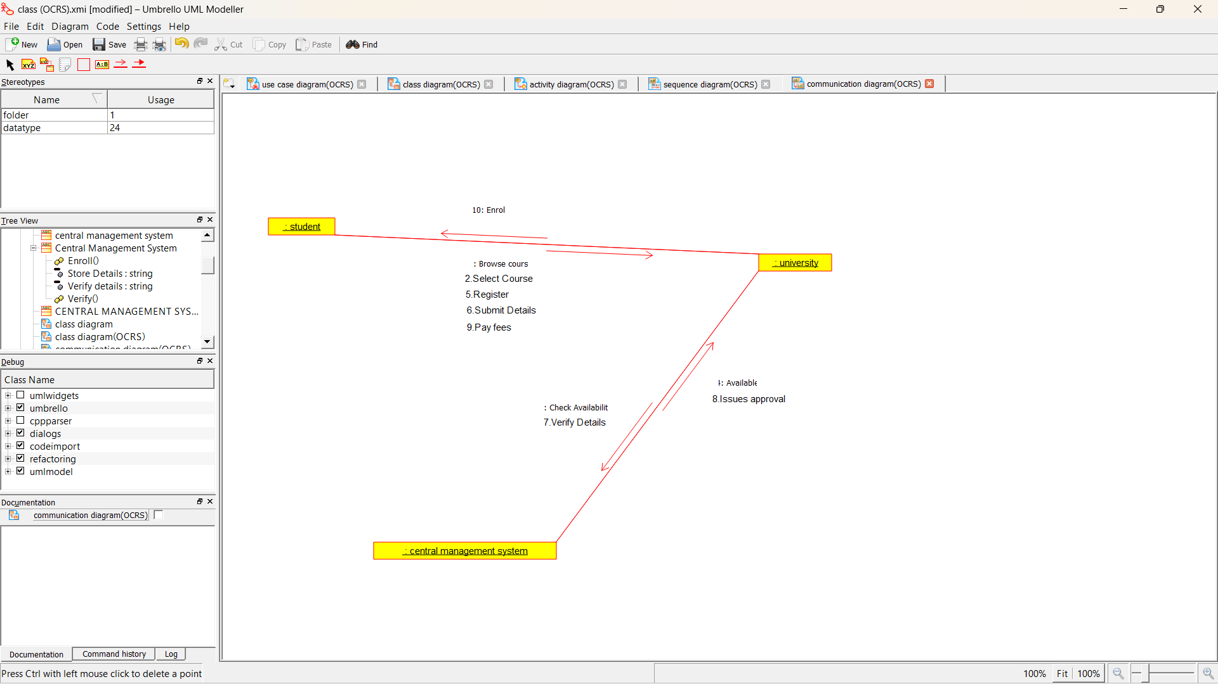

COMPONENT DIAGRAM:

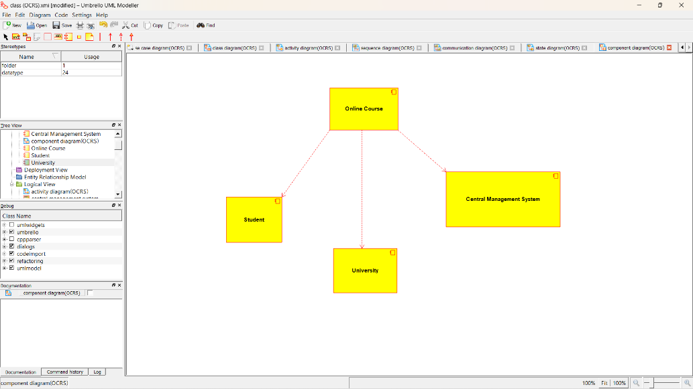

DEPLOYMENT DIAGRAM:

